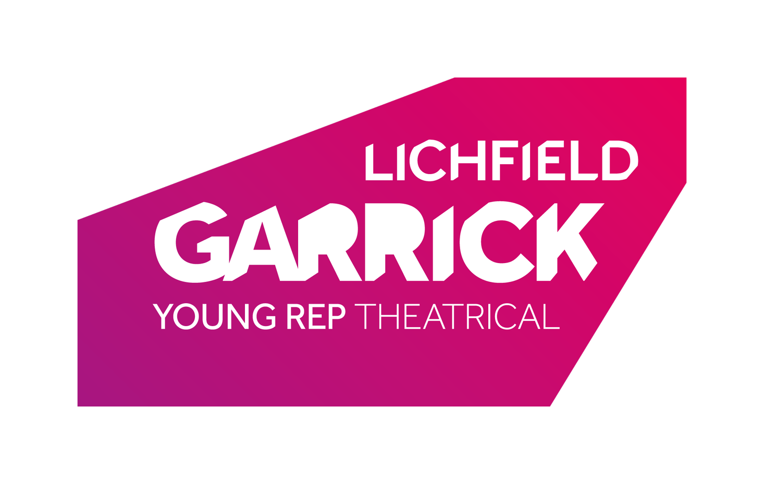
Garrick Juniors Application Form

Thank you for your interest in joining the Garrick Juniors. When completed, please return to Jonny McClean at the Garrick Theatre. Please leave at the box office or e-mail education@lichfieldgarrick.com. Please note each Term costs £120 and needs to be paid at the start of the term.

Please have a Parent/Guardian fill in all sides of the form.

Name:
Address:
Email Address:
Home Telephone:
Mobile:
Age:
Date of Birth:
Gender:
Do you have any access requirements?

Key dates
Garrick Juniors sessions will take place Saturdays 10:30am – 12:30pm, beginning 28/09/2019

Please tell us about any previous theatre & performing experiences that you have had:

Please tell us about any musical instruments you play (please include grade if applicable):

ARE YOU APPLYING FOR A BURSARY PLACE? YES / NO
If yes, you will be contacted in due course for more information.
We will use the contact details provided to inform you about rehearsals, performances, and other essential and practical details about your participation in this project.

PLEASE PROVIDE PARENT/GUARDIAN CONSENT FOR THE FOLLOWING (Please tick all that apply):
1. Future contact about similar learning projects by email
2. Use of image in rehearsal or performance photographs for promotion of this project or future Lichfield Garrick projects, including show programme, with name accompanying image
3. Use of image in rehearsal or performance photographs for promotion of this project or future Lichfield Garrick projects, including show programme, without name accompanying image
4. Permission for the child to leave the premises alone to make their own way home
If you would like more details on any of the above statements before consenting, then please get in touch as soon as possible using the details at the top of this form.

Your data will be kept for the duration of your time with the Garrick Juniors after which it will be securely disposed of. If you have given consent to option 1 of the above statements, then we will keep your data until two years after we cease to have any further interaction with you. If you have given consent for options 2-3 then we will keep your data indefinitely. You can withdraw consent or ask us to delete your data at any time.
PARENT/GUARDIAN SIGNATURE
. . . . . . . . . . . . . . . . . . . . . . . . . . . . . . . . . . . . . . . . . . . . . . . . . . . . . . . . .

MEDICAL DECLARATION

PLEASE GIVE DETAILS OF ANY MEDICAL CONDITIONS THAT WE SHOULD BE AWARE OF, INCLUDING ALLERGIES.
By doing so you give Lichfield Garrick permission to record and process this information should we require it to carry out our duty of care when you are on the premises as part of rehearsals and performance.

. . . . . . . . . . . . . . . . . . . . . . . . . . . . . . . . . . . . . . . . . . . . . . . . . . . . . . . . . . . . . . . . . .

The medical part of the registration form will be securely destroyed upon completion of the project.

