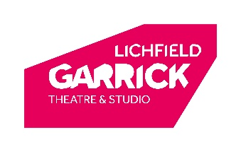
CHAIR & TRUSTEE RECRUITMENT
APPLICATION FORM

FOR ALL APPLICANTS

Name

Address:

Telephone:

Email:

Current Employment:

Other Trustee/Director Roles (if appropriate):

Please tell us why you’re interested in becoming a Trustee of Lichfield Garrick Theatre:

Please tell us about the professional and personal experience that you’d bring to our Board, highlighting where these relate to the priorities listed in the Recruitment Pack:

FOR CHAIR APPLICANTS ONLY

Please tell us about the experience that’d make you a great Chair of our Board:

I am interested in the possibility of a Co-Chair arrangement: YES / NO (please circle)

By applying I confirm that:
I do not have an unspent conviction for offenses involving dishonesty or deception;
I am not an undischarged bankrupt or someone with an Individual Voluntary Arrangement;
I am not on the sex offender’s register.

Please don’t worry about how much to write – we just want to hear about your experience
Please also attach a current CV and completed Equal Opportunities Monitoring Form
Please contact us if you’d like information in another format.
We’re happy to receive applications in different formats, for example as an audio or video file.
We will only share your application with people directly involved in this recruitment process.

