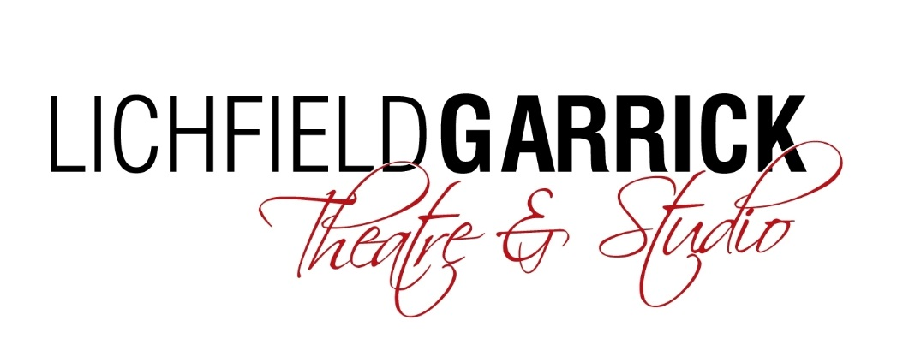
Commercial and Catering Manager

Thank you for your interest in the Commercial and Catering Manager post at the Lichfield Garrick.

Please find a job description and some background information enclosed.

How to Apply:
Please complete an application form and equal opportunities form (available for download from our website - www.lichfieldgarrick.com) and send it to:

Karen Foster, Executive Director, Lichfield Garrick
Castle Dyke, Lichfield WS13 6HR

Or by email to: garrick@lichfieldgarrick.com

Deadline for applications is midday on Monday 15th January 2018

Monday 15th January 2018 Application Closes
Monday 29th January 2018 Assessment Centre (all selected candidates)

We look forward to receiving your application and thank you for your interest in Lichfield Garrick.

Karen Foster

Background information

Lichfield Garrick is a producing house, a receiving house, a cultural hub at the heart of the city and district of Lichfield and has a thriving community and outreach programme. As a modern, purpose built theatre in Lichfield, the Garrick has an enviable programme of performances including drama, musicals, comedy, jazz, film and local theatre. This year we commissioned and produced our own ‘Letters to Emma’ which we hope will tour. We have also produced our own highly acclaimed panto, which this year is Aladdin starring Cat Sandion from CBeebies and a community musical, The Dreaming, which received huge amounts of critical acclaim.

The main auditorium seats around 550 people, with no restricted viewing and allocated wheelchair spaces. The Studio is more flexible, offering an intimate space that can be arranged in a number of different layouts and seating up to 150 guests.

With a commitment to supporting the local community and the people within it, the Lichfield Garrick runs a number of programmes designed to offer opportunities, networking and placements in a professional environment. These include the Lichfield Garrick Young Rep and Community Choir, a soon to be launched ‘silver singers’ daytime choir and outreach work with schools and groups around the district. We also have business relationships and hire our premises for outside activities.

Our programme is strong on traditional drama, but we are also building a new work strand and aim to support local and emerging artists. We are building our family audience and have a strong music following. The variety of other performances also offers opportunities for patrons with a wide range of tastes to enjoy a quality night out in the heart of the beautiful city of Lichfield. We are delighted that the theatre is now attracting help and advice from the Arts Council England and we aim to turn this into support by way of grants in the future.

A recently built community stage supports local artists and we welcome visual artists to the theatre by offering gallery space. This new space has helped us welcome in many new groups each week including an over 55’s Community group - The University Of The Third Age, South Staffordshire College, Inter-Theatre Company - an adult disability theatre company supporting local people with a wide range of disabilities and a monthly mental health support group for local people.

We have a grant from our Local District Council, but in the current public funding situation, this is being reduced and we aim to introduce more commercial income streams to close this gap. This role will lead on increasing business and yield from the Green Room, building additional spend across the building and working with the Executive Director to deliver new and potentially external income streams to help support the core business of providing the best entertainment and community activities possible.

JOB DESCRIPTION

Post: Commercial and Catering Manager

Reporting to: Karen Foster (Executive Director)

Responsible for: Green Room staff, Deputy Front of House Manager, Events and Box
Office Manager (events only)

Overview of the post:

1. To lead and manage the Green Room café and bars.

2. To increase all income generating activities within the building, with particular emphasis on building daytime take in the Green Room, night time sales in bars and additional spend on merchandise.
3. To manage department budgets, ensuring that Green Room activities are fully costed, gross profit budgeted and monitored, additional spend is monitored and increased, that budgets are set, monitored and adhered to in order to maximise profit. Ensure that all income streams match or exceed budget.
4. To manage the Front of House department ensuring that additional spend and income generating activities are monitored and that budgets and targets are met.
5. To work with the Executive Director to build new income streams.
6. To manage and drive commercial events and hires.
Main Duties
Green Room Café and Bars:
- To manage the Green Room Café and bars to ensure that profit is maximised.
- To develop the Green Room strategy, identifying and targeting potential customer groups, building a menu and offer to suit these demographics and planning commercial activities to implement these plans.
- To set budgets in association with Executive Director, to monitor activities and spend throughout the year and to report to Executive Director how sales and budgets are progressing.
- To ensure that Green Room and bars activities are fully costed, gross profit levels maintained and that staffing is adequate for the level of customer activities. To lead on developments to the Green Room and bars in consultation with senior staff, ensuring that business cases are prepared and followed. To lead on negotiations with contractors, ensuring best value on all arrangements.
- To oversee procedures for ordering stock, overs and unders, stock write off etc, in order to ensure the most efficient use of resources
- To undertake, in conjunction with other departments publicising Green Room activities and organising income generating activities. This should include seasonal and show related themes, allowing for innovative marketing within venue brand guidelines through publicity, social media, events and offers.
7. To oversee the Front of House department. Through the Front of House Manager, organise training & recruitment to ensure that professional standards of behaviour are set and maintained. Oversee the induction of new staff.
8. Identify and implement additional spend strategy, taking responsibility for ensuring that Front of House team are trained in sales techniques, are incentivised to deliver results and that all members of the FoH team have a consistent approach.
9. To ensure that there are sufficient trained staff to run the venue at all times and within licensing legislation. To ensure that personal licence is in place and that the staff lists are up to date.
10. With the Events and Box Office Manager, drive income generation through non-artistic hires. Be creative in finding and delivering commercial events
11. To assist the Executive Director in creating new income streams which may include external activities as well as those taking place within the theatre. This may include contributing to funding applications, financial forecasting, costing and planning. Commercial acumen will be required.
12. To be a duty manager, taking responsibility for the building and its security.
13. To be a key holder.
14. Excellent communication with all staff and line manager.
15. Oversee and ensure the implementation of all Lichfield Garrick Health & Safety policies including risk assessments and regular reporting for the whole of the front of house areas and activities.
16. To maintain a high quality physical environment throughout all Front of House areas within the Lichfield Garrick and take responsibility for planning the maintenance and/or replacement of equipment.
17. Any other duties requested by the Executive Director, appropriate to the role.
The Lichfield Garrick reserves the right to vary the content of the job description, after consultation, to reflect the changes to the job without changing the general character of the post or level of responsibility.

This job description is subject to review

PERSON SPECIFICATION

Essential

- Experience of managing a café, bar or restaurant
- Experience of food and beverage preparation and service
- Exceptional communication skills, both written and spoken
- Absolute attention to detail
- Ability to prioritise and work to strict deadlines
- Goal oriented
- Knowledge of health and hygiene legislation and the ability to implement relevant policies
- Personal licence holder
- A high standard of organisation and efficiency
- Able to win new clients for events
- Confident networking with a range of clients
- Good team-working skills
- Ability to engage and motivate people from all different backgrounds
- Ability to self-start
- A genuine enthusiasm for theatre
- Computer literacy including a knowledge of till software and programming
- An up-to-date understanding of current issues and trends in catering
- A good range of useful contacts
- Creative mindset – with the aim of building up the bars and café

The successful candidate will have a proven track record in creating or managing a busy and profitable catering establishment, the ability to ensure standards of customer service are maintained at a high-level and with a knowledge of the latest trends in food and drink. A creative and innovative person, they will be happy to introduce new ideas, research new products and procedures and to implement a programme of events which will be beneficial to the theatre.

Desirable

- A basic understanding of financial budgets and annual accounting.
- Previous experience working in a theatre or venue environment

TERMS OF EMPLOYMENT

Salary: £25,000

Period of contract: Permanent, including a six-month probationary period

Hours: 40 hours per week – flexible to suit work patterns
Some evening and weekend work will be required, an informal Time Off In Lieu system operates.

Holiday: 28 days per annum, 8 of which are Bank Holidays

Notice Period: 2 months

