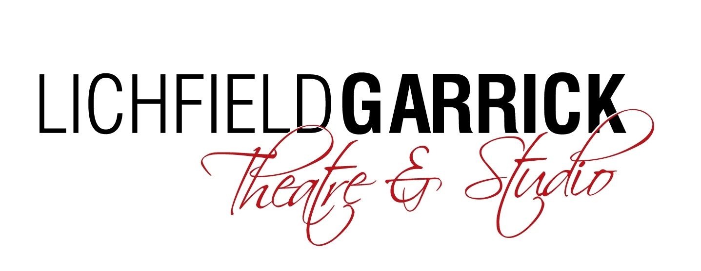
Community Stage Events Form
Please fill in and return this form to: education@lichfieldgarrick.com
Name of Organisation / Group / Artists
Event name:
Preferred Event Date:
Preferred Event Timings: | Start: |  | Finish:
Set Up Timings: | Please state preferred arrival time for any rehearsal or set-up
Expected Audience Numbers: | (Maximum capacity is 60 people including performers)
Participant Numbers: | (Please state maximum capacity if appropriate)
Access Requirements: | Yes / No if Yes please state:
Main Event Contact: | Please provide email address and telephone number
Garrick Contact: | Jonny McClean
Event Description | Please provide as much detail as possible and include any details you think we will need to be aware of from a Health and Safety perspective, if you have a running order please also supply this.
Comms Information | What is your target audience?  May The Garrick photograph the event?  Are any participants under 16 taking part?  Please provide an 140-character tweet about the event:  Please state any website address:  Please state any Twitter account:  Please attach any imagery or logos (max three items)

Signage to event Required? | Please provide what you would like any internal signage to the event to state (max 25 words)  Sign stating where the workshops are e.g:
Space Layout: | Please either describe clearly or provide a diagram
Equipment Requirements: | (e.g number of chairs and tables etc, or any special furniture requests)
Technical Requirements: | (e.g PA system/projector/projector screen etc)
Staffing Requirements | None
Cost Code:

