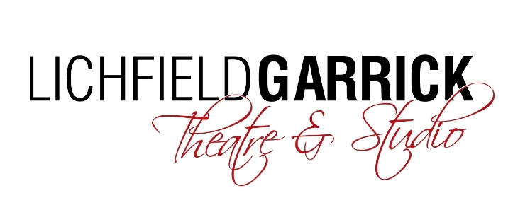
CHAIR ROLE DESCRIPTION
Lichfield Garrick Theatre seeks a highly motivated, well connected and locally based arts lover to lead the Charity and board of trustees. The theatre is a thriving, vibrant cultural hub at the heart of Lichfield, it attracts patrons from well beyond the local area as well as some of the top performers touring the UK. Its community and education work is building loyal and enthusiastic audiences, participants and practitioners.
The Board of Trustees needs to fulfil the modern-day requirements of an arts organisation, steering the charity, whilst providing access to philanthropic givers, influencing local stakeholders and offering specialist expertise when the business requires. The chair should be based locally, knowledgeable about the city and its infrastructure and enthusiastic about the role the theatre and the arts play in society. The chair should be skilled in running meetings to ensure that all trustees are able to input their views and experience. As volunteers, our trustees aim to support the theatre’s development by bringing their time and experience; it is hoped that our chair would be in a position to lead by example and that his/her enthusiasm and passion for the arts would help to guide the trustees’ decision making.

The statutory duties of a trustee
- To ensure that the Theatre pursues its objects as defined in its governing document
- To ensure the Theatre uses its resources exclusively in pursuance of its objects: the charity must not spend money on activities which are not included in its own objects, no matter how worthwhile or charitable those activities may seem
- To ensure that the Theatre complies with its governing document, charity law, company law and any other relevant legislation or regulations
- To contribute actively to the board of trustees’ role in giving firm strategic direction to the Theatre, setting overall policy, defining goals and setting targets and evaluating performance against agree targets
- To safeguard the good name and values of the Theatre
- To ensure the effective and efficient administration of the Theatre
- To ensure the financial stability of the Theatre
- To protect and manage the property of the Theatre and to ensure the proper investment of the Theatre’s funds
- If the Theatre employs staff, to appoint the Executive Director and monitor his/her performance
Other duties
In addition to the above statutory duties, each trustee should use any specific skills, knowledge or experience they have to help the board of trustees reach sound decisions. This may involve:
- Leading discussions
- Focusing on key issues
- Providing guidance on new initiatives
- Other issues in which the trustee has special expertise

Chair person specification
- Commitment to the theatre
- Support a culture which ensures equality and fairness for all, an inclusive programme and ethos, and a trail-blazing artistic role within our community.
- Willingness to devote the necessary time and effort
- Strategic vision
- Good, independent judgement
- Ability to think creatively and a willingness to speak their mind
- Leading discussions in a manner which ensures that all trustees’ opinions are heard
- Understanding and acceptance of the legal duties, responsibilities and liabilities of trusteeship
- Willingness to make and stand by collective decisions, including those which may be unpopular
- Ability to work effectively as a member of a team, building relationships with stakeholders including trustees, Garrick staff members, LDC and supporters
- Willingness to introduce supporters/donors to the theatre
- A wide range of contacts within Lichfield and local area

Lichfield Garrick Theatre Values
The theatre has espoused five values: community, communication, creativity, integrity and excellence as its guiding principles. The following actions are the trustees commitment to our values. Our values are not ordered in any order of merit or importance and thus are alphabetical below.
Community –
Be prepared to:
  - Commit to all meetings wherever possible in line with personal and other work commitments and, when not able to attend, give ample notice and, both prior and after the meeting, make an effort to bring yourself personally up to date.
  - Commit to getting to know other Trustees personally and develop positive and personal relationships, supporting them where possible.
  - Commit to getting to know the Garrick team and develop positive relationships, supporting them where possible.
  - Commit to personally understanding the Garrick customer and stakeholder community and understand their requirement from the Garrick offering.
  - Trustees should actively promote and advocate for the theatre in their own communities.
- Communication -
- Listen to other Trustees’ views and ideas and be prepared to have personal thinking challenged.
- Cultivate positive, regular and supportive mutual communication with the Garrick team.
- Be prepared for meetings and offer ideas and interaction in relation to the agenda items discussed
- External communication to be consistent and agreed, supporting corporate messages.
- Creativity –
- Not be afraid to use innovative thinking and be bold in decision making for the benefit of the Garrick’s sustainability.
- Enable the Garrick team to be bold and brave as they develop the vision for the Garrick’s future with the Board of Trustees.
- Suggest ideas and thoughts for innovation.
- Integrity-
- Be honest about thoughts, ideas and views in a positive and productive manner.
- Demonstrate positive ethics and behaviour that facilitates inclusive interaction with others.
- Be responsible when making decisions, always making them for the good of the Garrick, the team and the customer population.
- Show decency and fairness to all.
- Promote unity within the Trustee team and the wider Garrick, encouraging togetherness and solid team work.
- Trustees should balance the risk and reward of existing and innovative initiatives.
- Listen and report back to the senior management team on community comment and feedback.
- Excellence -
- Challenge our thinking and activity so that we are always striving to improve.
- Use our personal skill set to support each other as best we can, bringing our expertise and knowledge to challenges particularly relating to our own field.
- Encourage a high performing culture supporting continual personal development.

