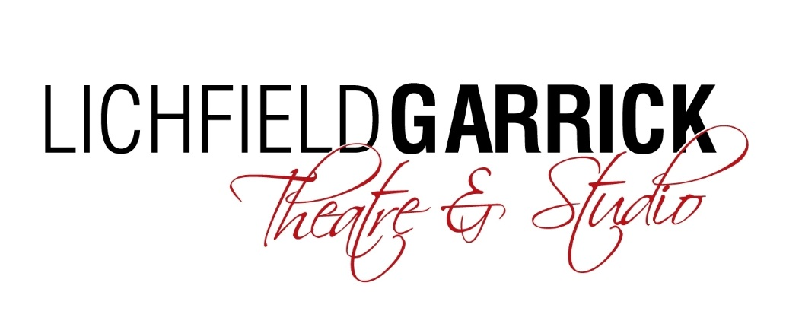

Artistic and Production Co-ordinator

Thank you for your interest in the Artistic and Production Co-ordinator post at the Lichfield Garrick.

Please find a job description and some background information enclosed.

How to Apply:
Please complete and return the application form and equal opportunities form from the website and return this to recruitment@lichfieldgarrick.com:-

Deadline for applications is 5pm on 25th March 2019.
Interviews will be during the week commencing 1st April 2019.

We look forward to receiving your application and thank you for your interest in Lichfield Garrick.

Background information

Lichfield Garrick is a producing house, a receiving house, a cultural hub at the heart of the city and district of Lichfield and has a thriving community and outreach programme. As a modern, purpose-built theatre in Lichfield, the Garrick has an enviable programme of performances including drama, musicals, comedy, concerts, film and local theatre. We have built up a huge following for our amazing pantos with Dick Whittington this year, bringing well over 30,000 people through our doors. Our summer time community musical attracts performers and audience from a wide range of people and this year our youth theatre will be performing as part of the NT Connections project.

The main auditorium seats around 550 people, with no restricted viewing and allocated wheelchair spaces. The Studio is more flexible, offering an intimate space that can be arranged in a number of different layouts and seating up to 150 guests.

With a commitment to supporting the local community and the people within it, the Lichfield Garrick runs several programmes designed to offer opportunities, networking and placements in a professional environment. These include the Lichfield Garrick Young Rep and Community Choir, the Morning Chorus daytime choir and outreach work with schools and groups around the district. We also have business relationships and hire our premises for outside activities.

Our programme is strong on traditional drama, but we are also building a new work strand and aim to support local and emerging artists. We are building our family audience and have a strong music following. The variety of other performances also offers opportunities for patrons with a wide range of tastes to enjoy a quality night out in the heart of the beautiful city of Lichfield. We are delighted that the theatre is now attracting help and advice from the Arts Council England and we aim to turn this into support by way of grants in the future.

We have a grant from our Local District Council, but in the current public funding situation, this is being reduced and we aim to introduce more commercial income streams to close this gap. This role will be supporting senior managers in bringing artists to the theatre as both received shows and as part of our own in-house productions. This role will also take the lead in developing our cinematic offering and building a new audience for this line of programming.

Job description

Role

- To programme commercially viable shows into the mainhouse and studio as directed by the programming committee and Executive Director.
- To provide administrative support for Lichfield Garrick Theatre in-house productions.
- To book cinematic screenings, including NT Live type productions, dealing with all administration about this programming stream
- To build an audience for cinematic screenings
- To offer administrative support to senior managers involved with artistic activities
- To book future tours for Lichfield Garrick productions.

Responsibilities

Programming:

- To receive information from producers, attend programming committee meetings and to negotiate deals with commercial producers as directed by the committee’s decisions.

- To programme and administer all aspects of our cinematic screenings, in consultation with senior colleagues.

- To create deal sheets for shows programmed by both the Executive Director and this role.

Artistic Administration:
- To work on the administration and production of Lichfield Garrick Theatre in-house shows. This will include, but not be limited to:
- Liaise with Artists and creatives of In-House productions, assisting with Digs, travel arrangements and general enquires.
- Deal with Artist expense claims and petty cash relating to Production Budgets.
- Distribute and collate Artist paperwork including scripts, scores and costume sizing information.
- Organise auditions and deal with all parties including young people at panto auditions.
- To administer the Lichfield Garrick’s choirs.
- To oversee invitations for potential touring partners to see in-house shows with a view to setting up future tours.
- To put together tours of LGT in-house productions. This will include contacting promoters and selling the show.
- To deal with complaints about shows, in liaison with the shows’ producers.

General
- Any other duties which may reasonably be requested by the Executive Director.
- To maintain a high standard of personal cleanliness and dress.
- Ensure that the Lichfield Garrick policies and procedures are followed at all times.
- Extensive knowledge of the theatre sector and network or contacts within the industry.

This job description may be varied and these roles should not be considered exhaustive.

PERSON SPECIFICATION

Essential Criteria | Desirable Criteria | Means of Selection
Experience  A passion for understanding of regional theatre and its national context.  Initiative and confidence in dealing with people and tasks, but with a strong understanding of when to ask for help and guidance.  Ability to maintain confidentiality.  Strong negotiation skills and the ability to ensure value for money.  Computer literate (use of Word, Excel, Internet Explorer/Chrome and Outlook to a competent level).  Awareness of Health and Safety Legislation and good practices.  Ability to prioritise and work to strict deadlines.  Good teamworking skills. | Theatre programming experience.  Experience of producing and managing professional theatrical productions. | Application Form / Interview  Application Form / Interview  Application Form / Interview  Application Form / Interview  Application Form / Interview  Application Form / Interview  Interview

Qualifications  Tertiary education | Degree level study, possibly in an arts subject. | Application form /  Interview
Skills and Abilities  Excellent communication and people skills.  Theatre or touring experience.  Knowledge of theatre protocol.  Ability to work well under pressure and remain calm in a busy environment.  Ability to pay close attention to detail.  A high standard of organisation and efficiency.  Ability to work as part of the Lichfield Garrick management team. |  | Application form/ interview  Application Form / interview  Application Form / interview  Application Form / Interview  Application Form / Interview  Application Form / Interview  Interview
Special Attributes  Able to work flexible hours to fit with the Theatre, which will include evenings, weekends and Bank Holidays. |  | Interview

TERMS OF EMPLOYMENT

Salary: £20,000 - £25,000 pa, depending on experience.

Period of contract: Permanent, including a six-month probationary period.

Reports to: Executive Director.

Notice Period: 2 months following a six month probationary period.

