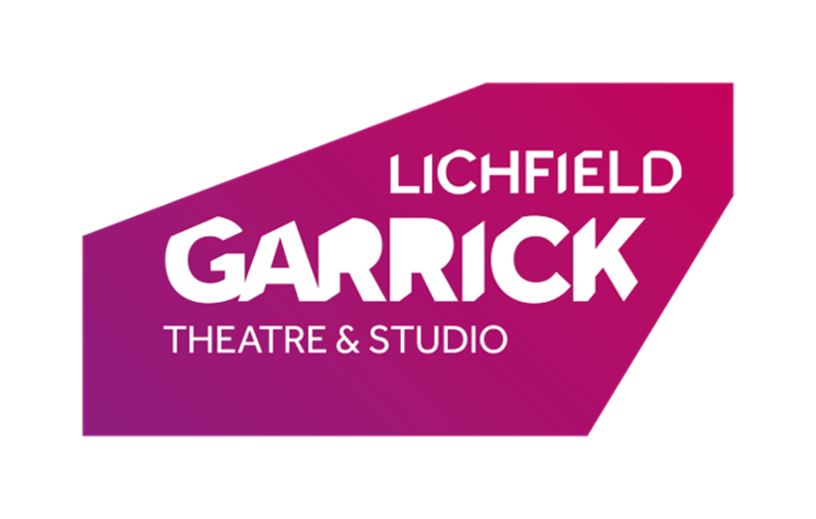
Lichfield Garrick Youth Board Of Directors 2022 Application Form

Please Read/fill in all sides of the form and the declaration.

Name:
Address:
Email Address (Of Parent/Guardian if Under 18):
Home Telephone:
Mobile (If under 18 please ignore and fill out the below):
If under 18
Parent/Guardian/Carer Name:
If under 18
Parent/Guardian/Carer Mobile:
Age:
Date of Birth:
Gender Pronouns (e.g her/she, he/him, they/them):
Do you have any access requirements?

Key Information

Applications close on 21st November 2022.

You must be between the ages of 13-25 for the duration of this project in order to take part. Applications outside of this age bracket will not be considered.

Meetings will be once a month, on dates agreed with the Youth Board.

Dependent upon candidate numbers, you may be invited to an open evening so that we can meet you and you are able to learn more about the theatre. The date for this is TBC. If you are unable to attend the date, it will not affect your Youth Board application.

Why would you like to be a member of the Lichfield Garrick Youth Board of Directors?

Your data will be kept securely in case of necessary review up until 01/08/2038. If you have given consent to option 1 of the above statements, then we will keep your data for marketing purposes until two years after we cease to have any further interaction with you. You can withdraw consent or ask us to delete your data at any time.

